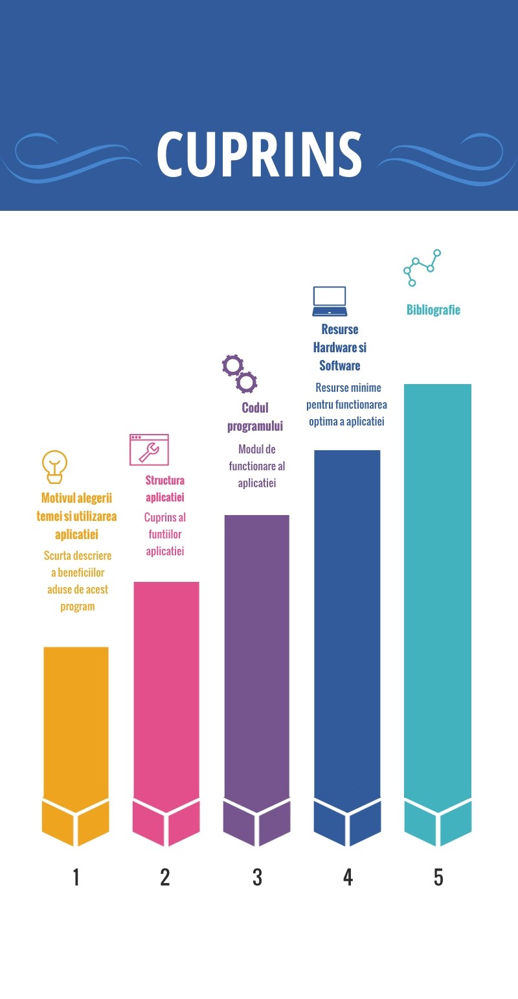

1. **Motivul alegerii temei si utilizarea aplicatiei**

Am ales aceasta tema datorita pasiunii pe care am dezvoltat-o pentru astronomie, in gimnaziu. Desi nu se mai regaseste in programa scolara, astronomia reprezinta pentru mine, un punct de interes pana si in momentul actual. Consider ca informatia adusa de aceasta materie, poate atrage si generatiile mai mici, daca le este prezentata intr-un mod care sa le atraga atentia in directia corespunzatoare. Din acest motiv am ales sa creez o aplicatie care poate fi folosita cu scop educativ, bazata pe idea de “invatam jucandu-ne”.

Aplicatia cuprinde o serie de jocuri, informatii si chestionare pentru verificarea cunostiintelor acumultate. In cateva pagini am reusit sa comprim informatia de baza pentru un bun inceput in cadrul astronomiei. Proiectul fiind dedicat copiilor de o varsta mai mica, estetica lucrarii a fost aleasa in asa fel incat sa aduca a desen animat, tocmai pentru a crea o punte de legatura cu aria de interes a utilizatorului. Totodata, in partea axata pe constelatii, sunt incluse informatii putin mai complexe, care pot ajuta la concursurile scolare, atat la o posibila etapa locala, cat si la una nationala.

In aplicatie sunt cuprinse 3 jocuri: 2 de memorie si un “Flappy Rocket”. Acestea au in principiu scop recreativ, dar sunt facute sa-ti si reinprospateze putin memoria in legatura cu imaginea planetelor si constelatiilor, de unde si numele de “Memory Game”. Jocul are un concept simplu si usor de intels. Se da o pagina cu un set de cartonase amestecate si intoarse cu spatele. Scopul este ca jucatorul este sa gaseasca intr-un timp cat mai scurt perechile de carti identice pana dispar toate de pe ecran. Celalalt joc, are in totalitate scop recreativ, fiind vorba despre o racheta care trebuie sa treaca prin niste obstacole.

Testele de verificare sunt si ele folositoare si te ajuta sa-ti cunosti nivelul la care te afli la momentul respectiv. Daca gresesti o intebare, nu este nicio problema, poti reveni mai tarziu cand te vei simti cu adevarat pregatit!

Acestea fiind spuse, bun venit in clubul de astronomie!

**2. Structura aplicatiei** 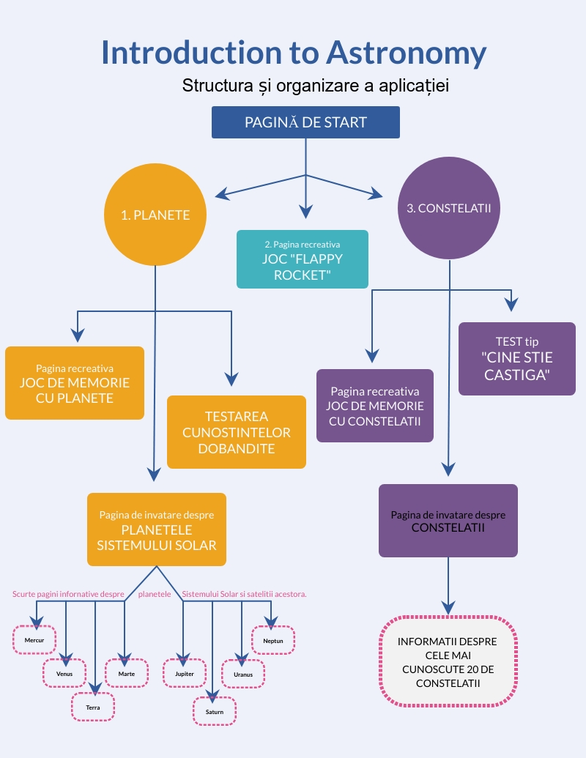

**Detalii de accesare si explicarea codului sursa**

Pagina principala a aplicatiei contine trei butoane. Cele doua laterale, marcate ca **“PLANETS”** si **“CONSTELLATIONS”**, deschid pagini tematice cu caracter educativ, iar cel de-al treilea **“PLAY!”**, pozitionat median trimite la o noua pagina, interactiva , continand un joc **“FLAPPY ROCKET”**.

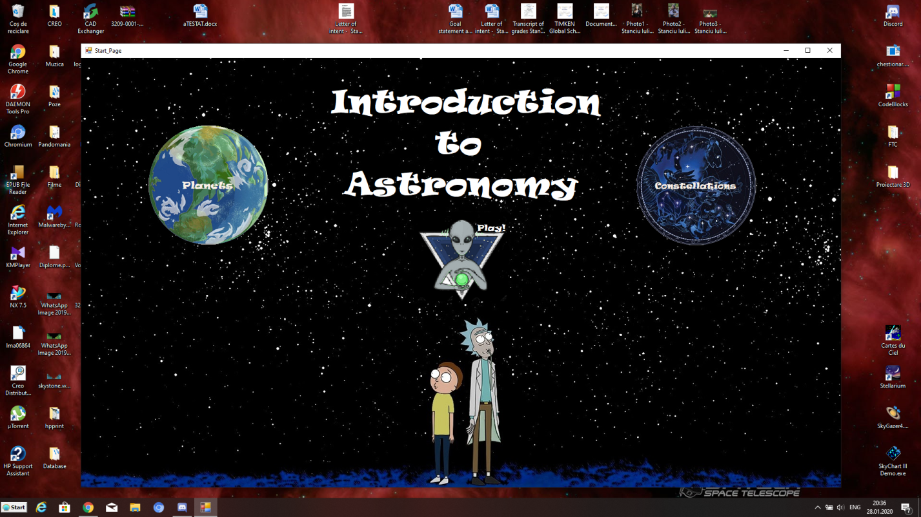

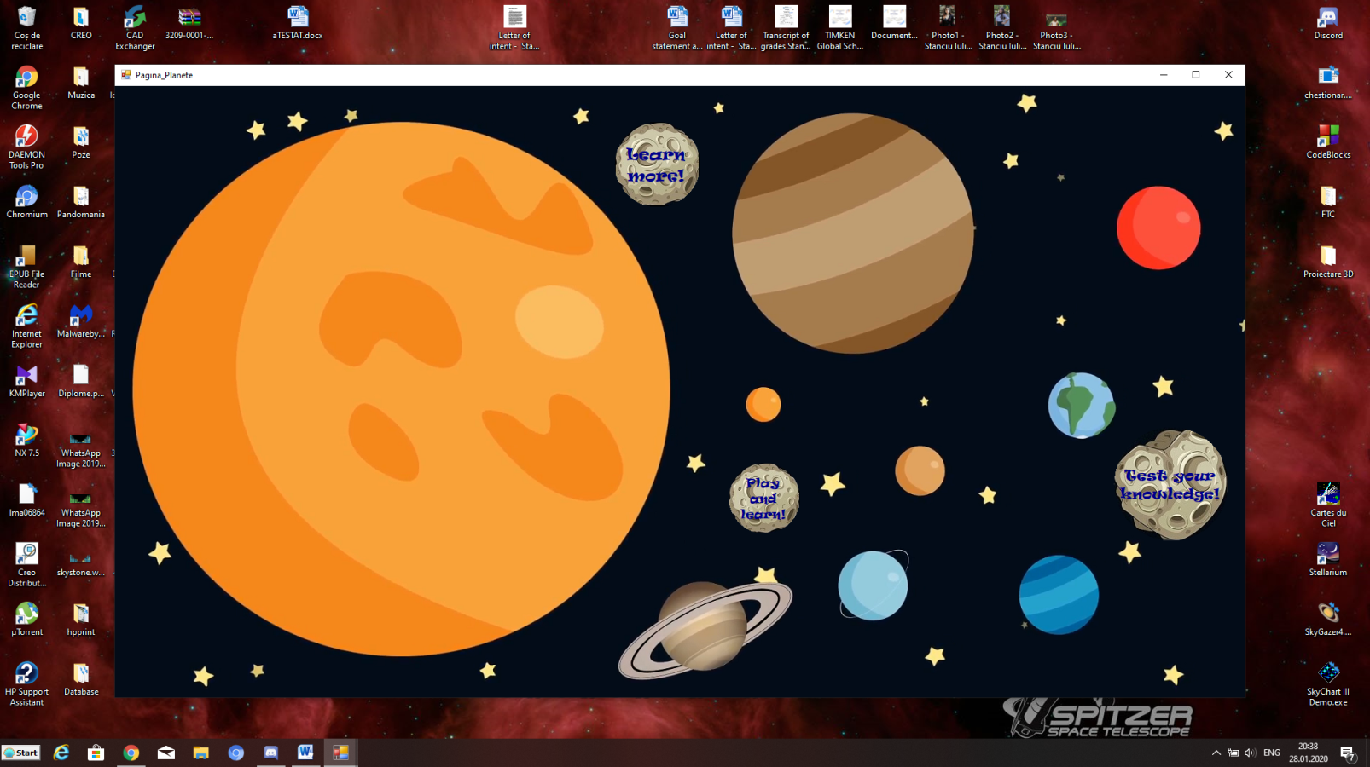

Apasand pe butonul **“PLANETS”,** este deschis un meniu cu trei optiuni:

* **“Learn more!” –** pagini cu informatii de baza despre planetele Sistemului Solar.
* **“Play and learn!” –** joc de memorie destinat copiilor de radinita si clase primare cu scopul de a-i familiariza cu imaginea corpurilor celeste.
* **“Test your knowledge!” –** test verificare a cunostintelor acumulate prin citirea informatiei de pe platforma informativa.

1. **Platforma de invatare**

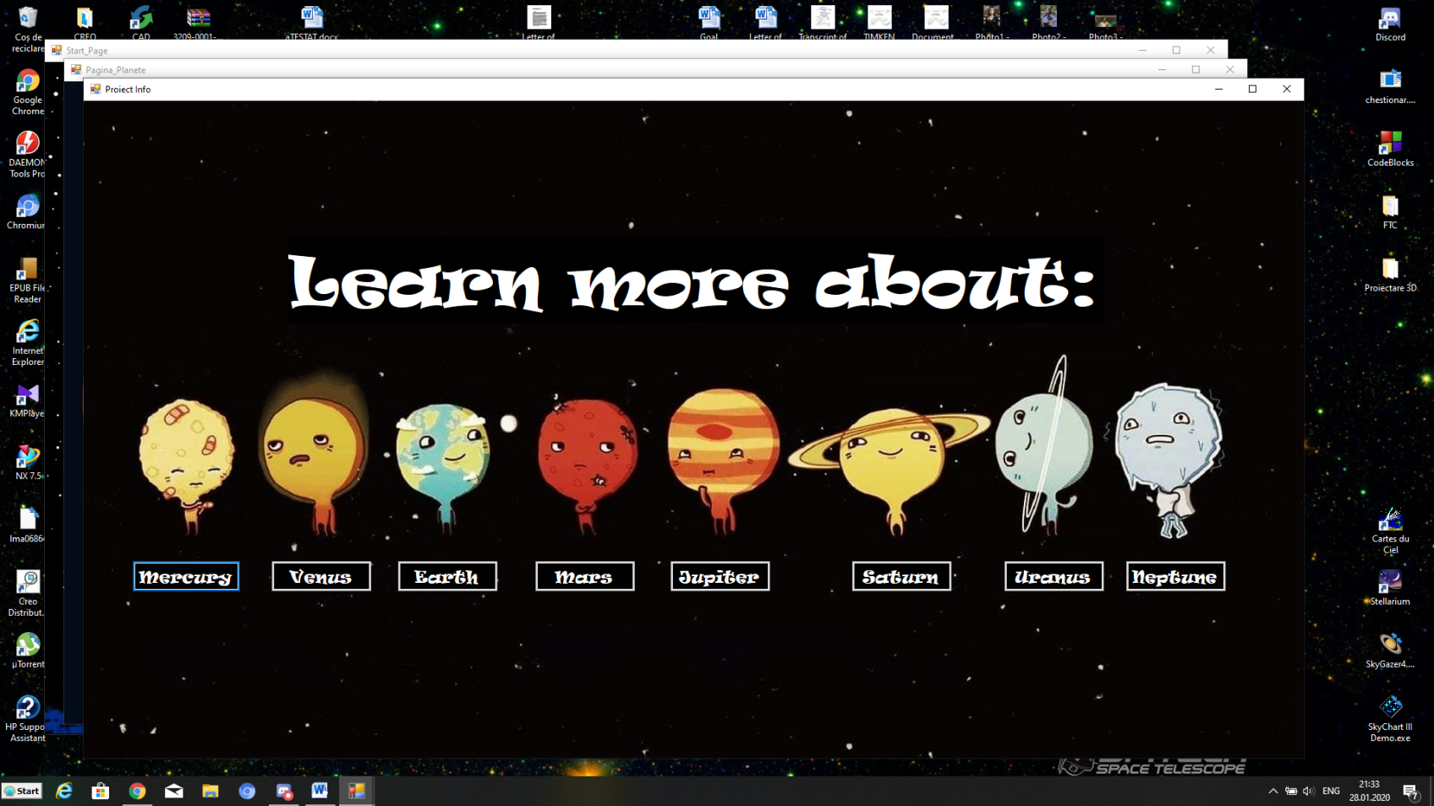Platforma de invatare este constituita de 8 pagini tip caseta cu imagini si informatii semnificative privind Pamantul si planetele cele mai apropiate acestia. Informatia este structurata logic, urmarind atat caracteristici fizice si chimice. Pozele detaliate pot, de asemenea, sa fie marite prin apasarea pe acestea.

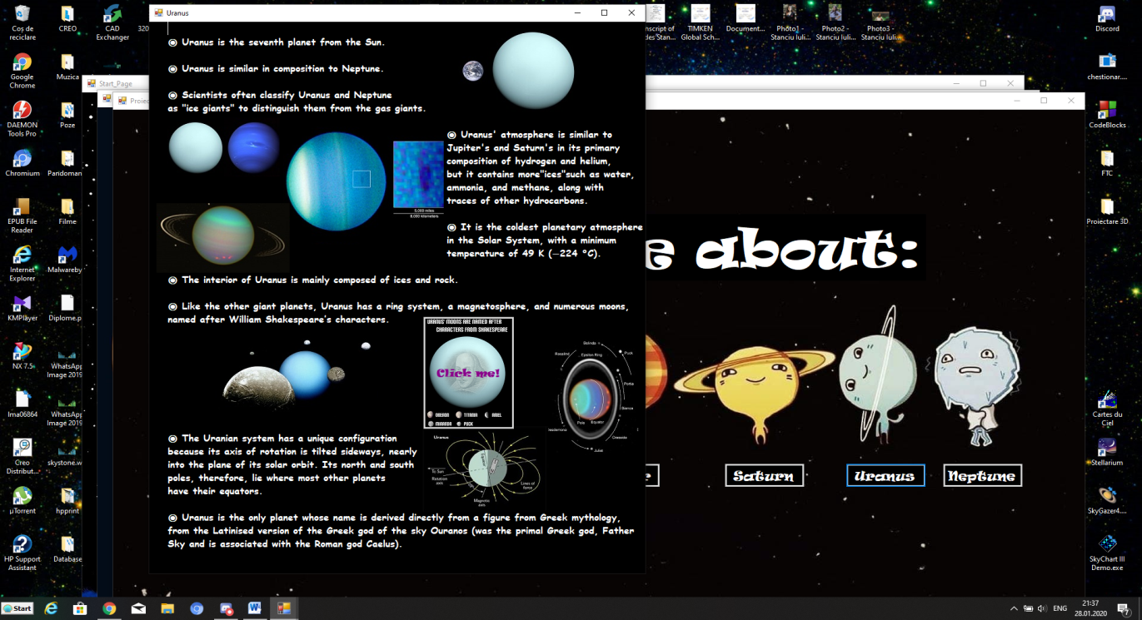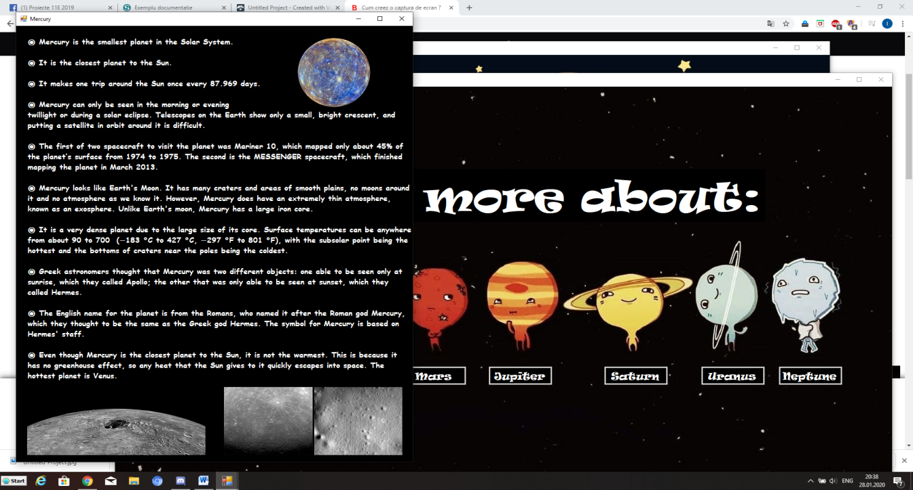

1. **Platforma de testare a cunostintelor**

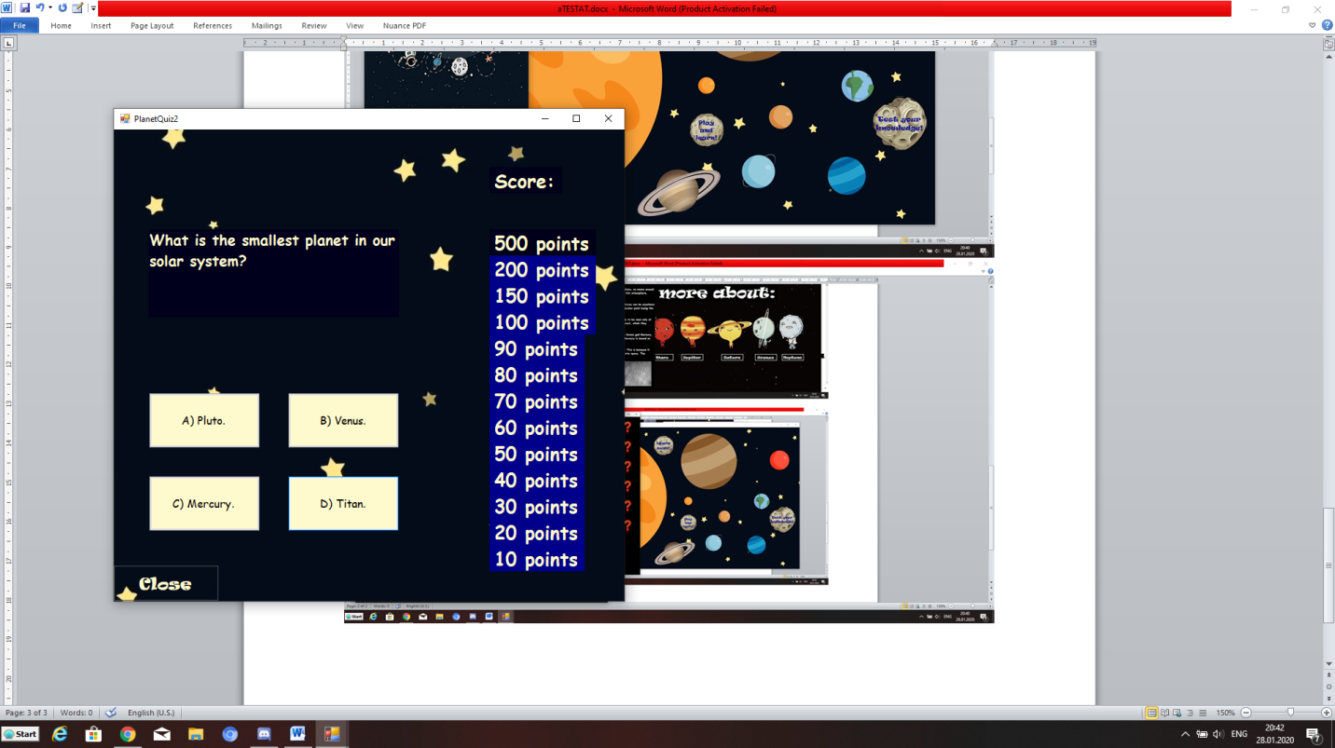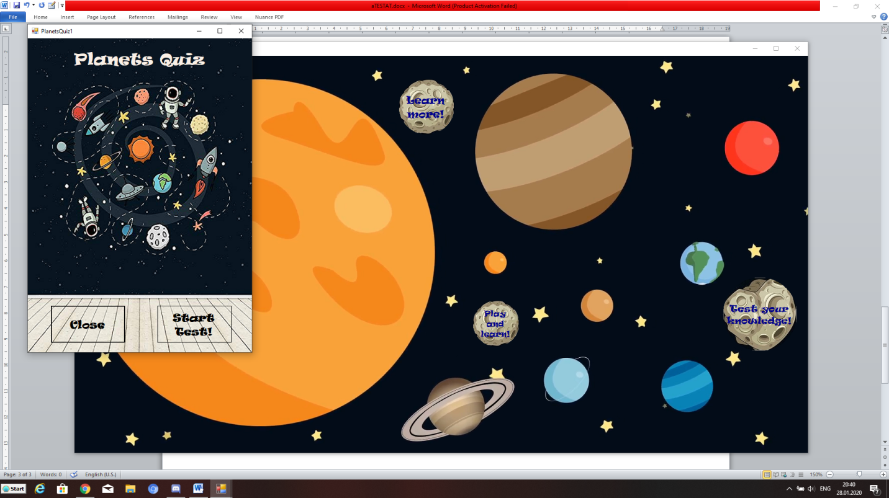 Verificarea cunostintelor acumulate in lectiile anterior studiate se poate face de asemenea in cadrul aplicatiei. Butonul “Test your knowledge!” deschide un test de cultura generala pe tema astronomiei si predominant a planetelor. Testul este grija, iar fiecare intrebare are un singur raspuns corect. Fiecare intrebare are atribuit un numar de puncte pe care jucatorul le va acumula treptat.

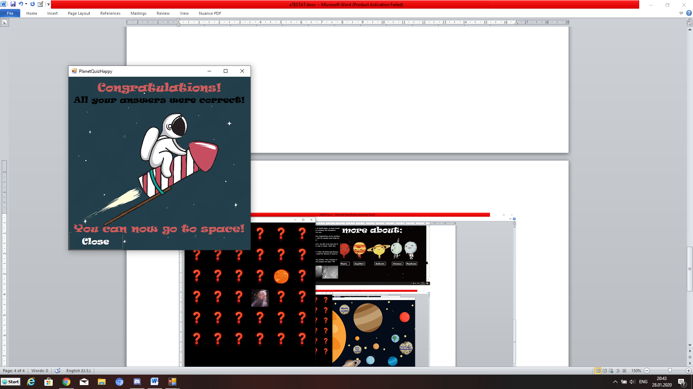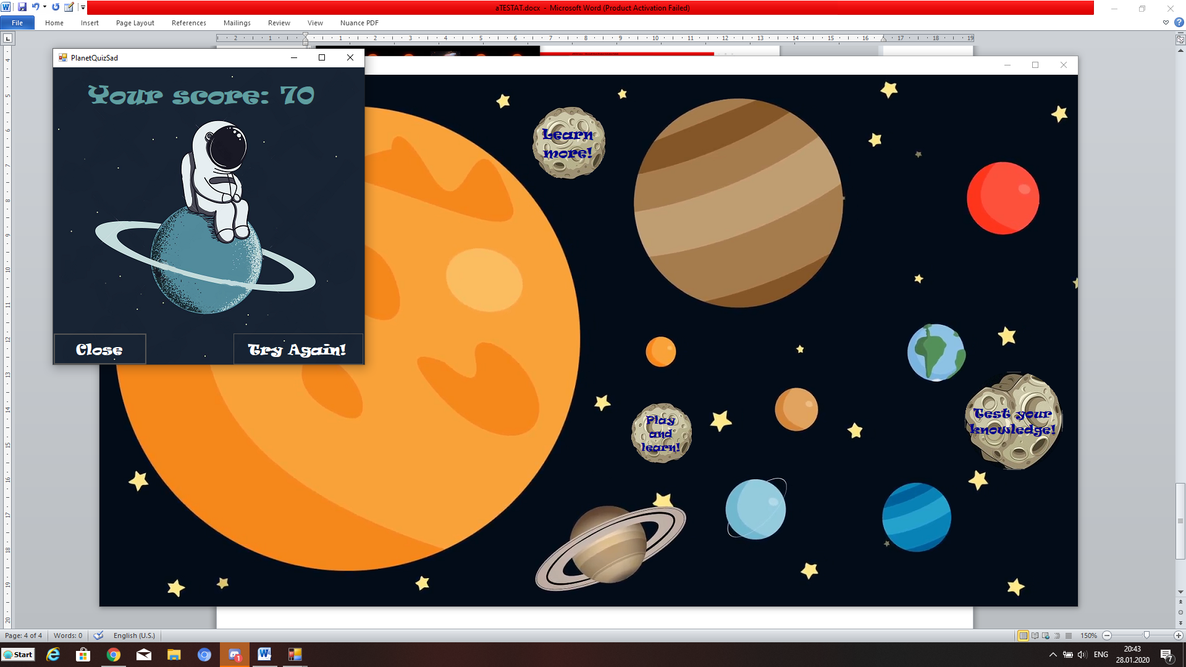Jocul se sfarseste la primul raspuns corect sau atunci cand jucatorul raspunde corect la toate cele 13 intrebari si acumuleaza un total de 500 de puncte.

1. **Platforma recreationala**

Aplicatia include un joc de memorie dedicat copiilor de varste mici si medii. Motivul creeri jocului a fost dorinta de a implini nevoia celor mici de cunoastere a lumii inconjuratoare.

Mod de funtionare:

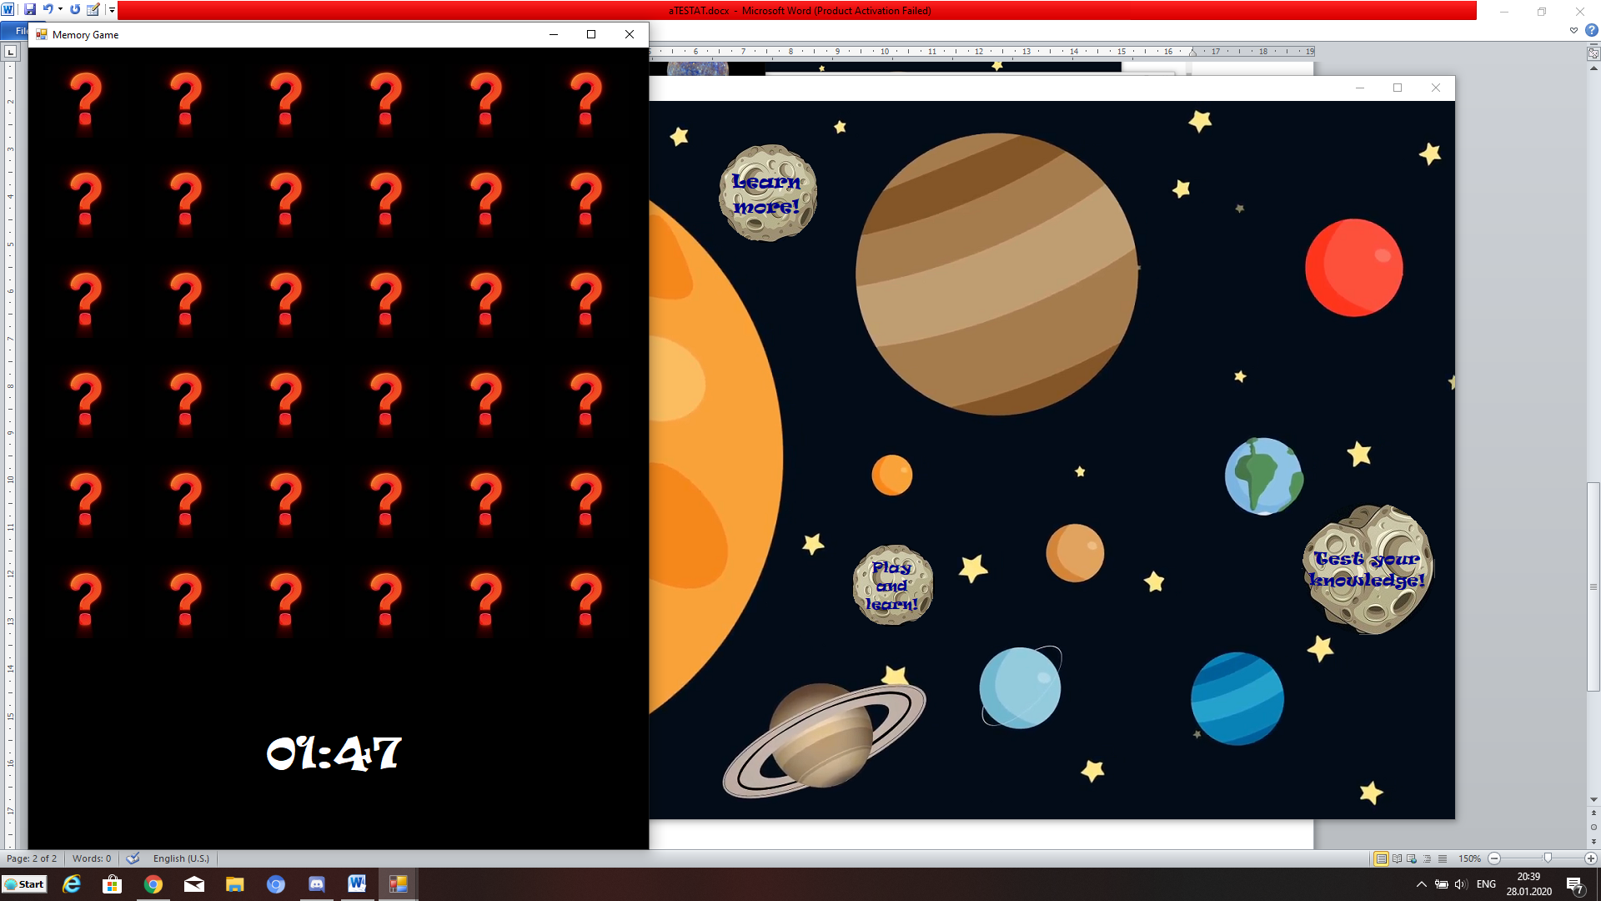 Initial, toata pozele sunt acoperite de un fundal negru cu un semn de intrebare. Acesta dispare odata ce este apasat. Doar doua imagini pot fi dezvaluite in acelasi timp. Daca acestea sunt identice, vor disparea. Daca sunt diferite, vor fi acoperite din nou. Jucatorii au la dispozitie 2 minute pentru a gasi pozele identice si a le imperechea.

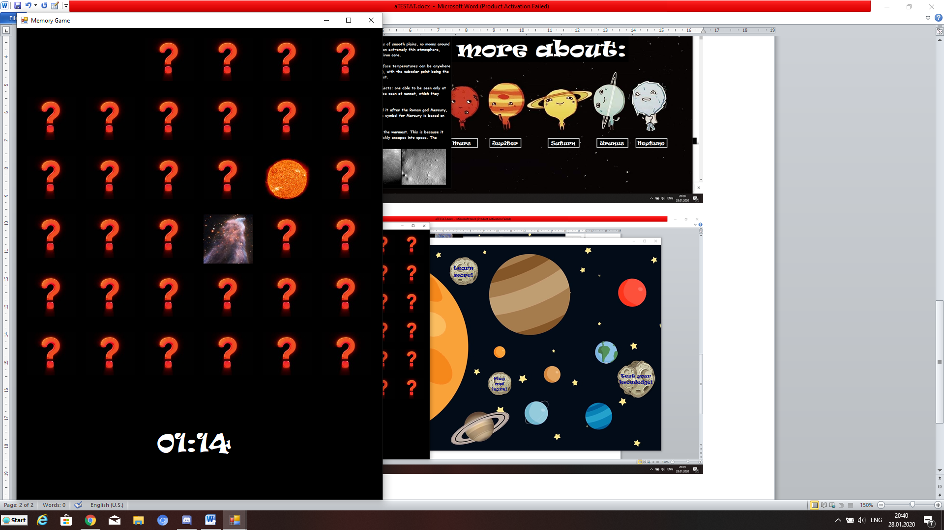

Pozele identice au disparut.

Pozele diferite sunt vizibile pentru o secunda.

Timpul incepe la 2 minute si se opreste la 00:00.

Apasand pe butonul **“PLAY!”,** este deschisa o noua fereastra continand un Joc**: “FLAPPY ROCKET”**. Aplicatia cu scop recreativ a fost ceeata dupa modelul FLAPPY BIRD. Scopul jocului este sa petreci cat mai mult timp fara a lovi racheta de obstacole.

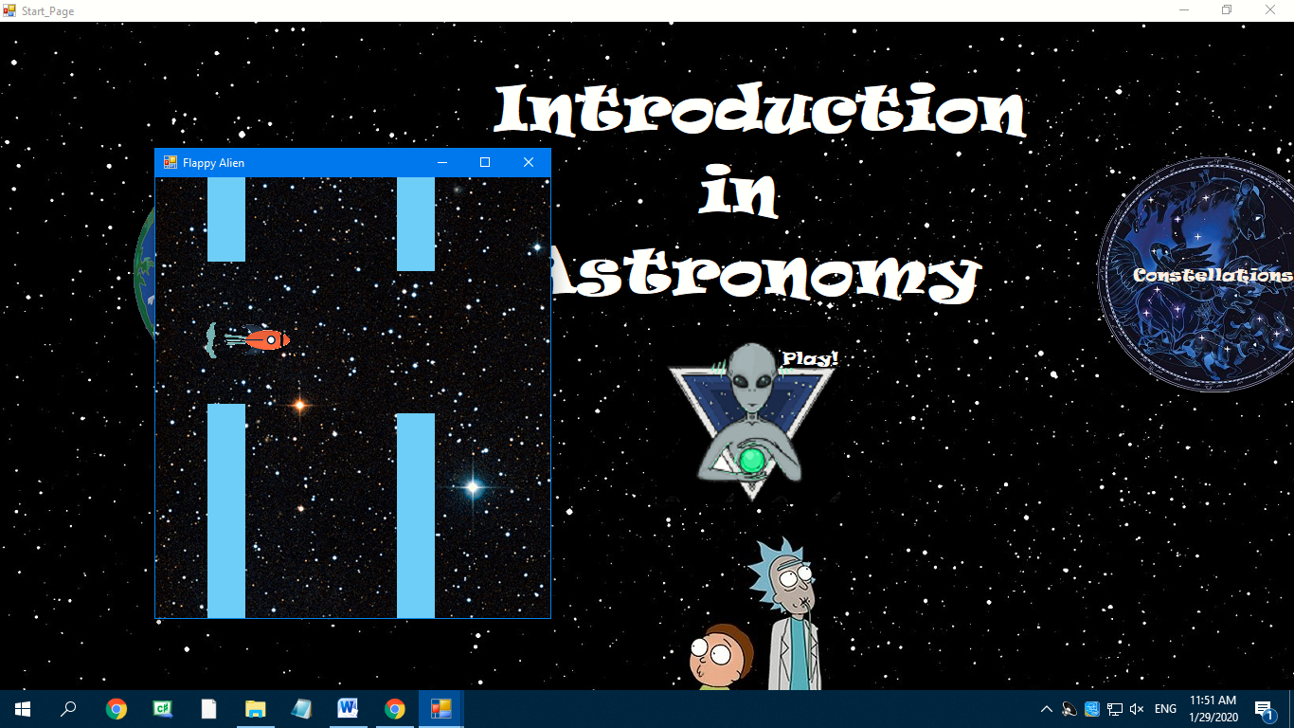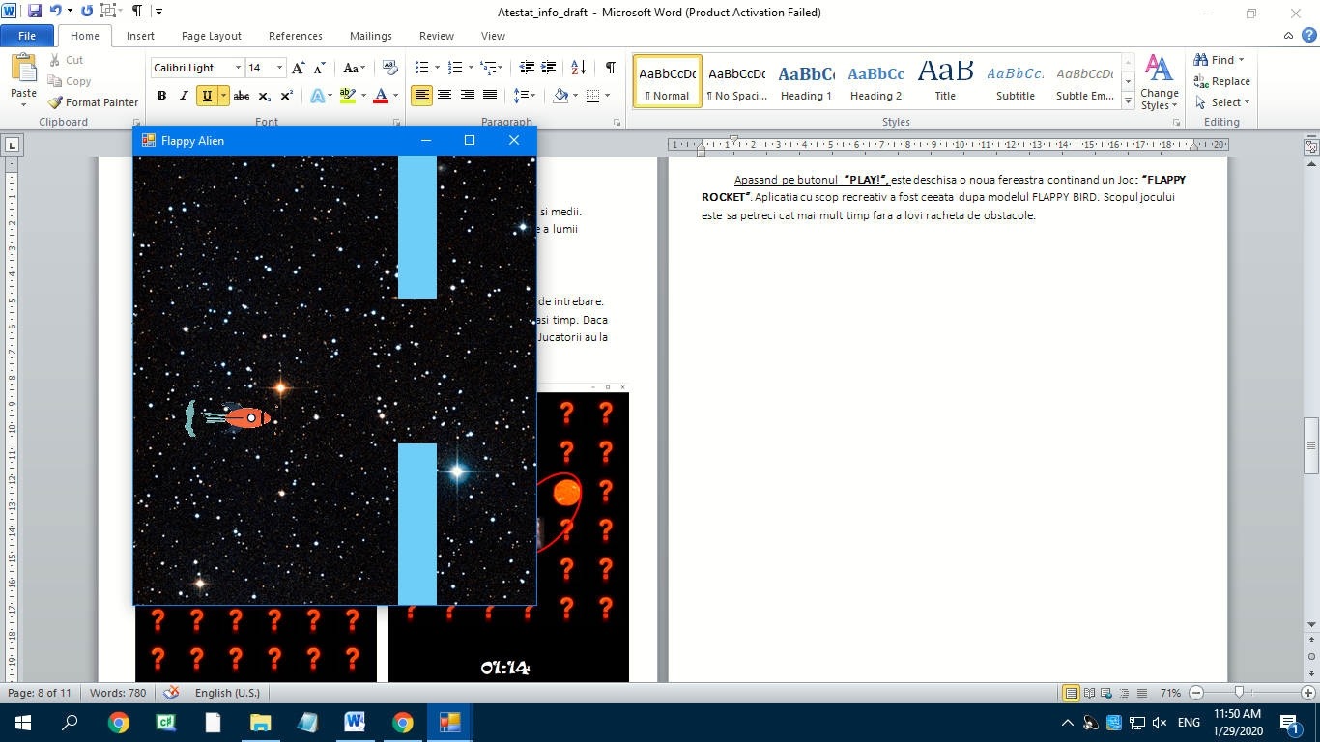

Racheta este actionata de butonul **SPACE**, iar jocul se termina odata ce aceasta se loveste de un obstacol.

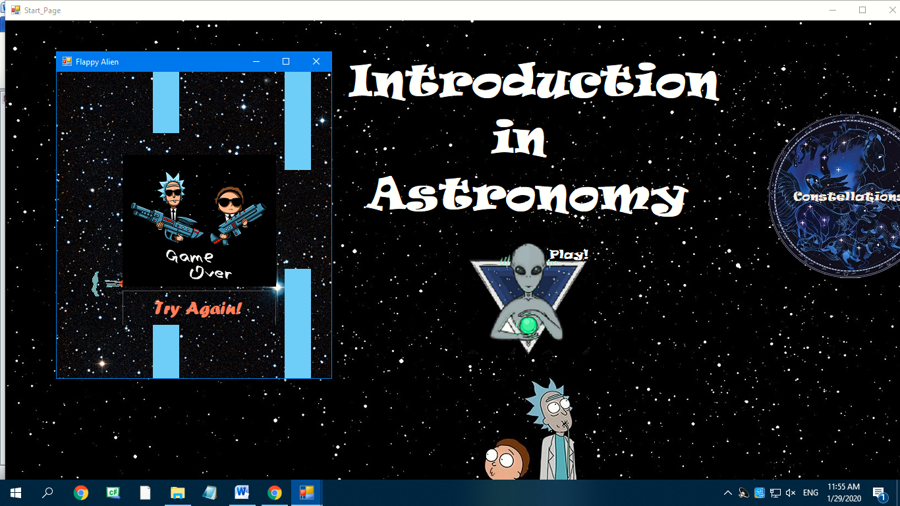

Apasati butonul pentru a juca inca o data.

**4. Codul sursa**

1. **PAGINA PRINCIPALA**

using System;

using System.Collections.Generic;

using System.ComponentModel;

using System.Data;

using System.Drawing;

using System.Linq;

using System.Text;

using System.Threading.Tasks;

using System.Windows.Forms;

namespace chestionar

{

public partial class Start_Page : Form

{

public Start_Page()

{

InitializeComponent();

}

private void Start_Page_Load(object sender, EventArgs e)

{

}

private void buttonPlanets_Click(object sender, EventArgs e)

{

Pagina_Planete newform = new Pagina_Planete ();

newform.Show();

}

private void buttonConstelations_Click(object sender, EventArgs e)

{

Pagina_Constelatii newform = new Pagina_Constelatii();

newform.Show();

}

private void FlappyAlienButton_Click(object sender, EventArgs e)

{

FlappyAlien newform = new FlappyAlien();

newform.Show();

}

}

}

1. **PAGINA PLANETE**

using System;

using System.Collections.Generic;

using System.ComponentModel;

using System.Data;

using System.Drawing;

using System.Linq;

using System.Text;

using System.Threading.Tasks;

using System.Windows.Forms;

using System.Drawing.Drawing2D;

namespace chestionar

{

public partial class Pagina_Planete : Form

{

public Pagina_Planete()

{

InitializeComponent();

}

private void Pagina_Planete_Load(object sender, EventArgs e)

{

}

private void buttonTeorie_Click (object sender, EventArgs e)

{

Teorie_Planete newform = new Teorie_Planete();

newform.Show();

}

private void buttonJoc_Click(object sender, EventArgs e)

{

Joc_Planete newform = new Joc_Planete ();

newform.Show();

}

private void RoundButtonChestionar_Click(object sender, EventArgs e)

{

PlanetQuiz1 newform = new PlanetQuiz1();

newform.Show();

}

}

}

1. **PAGINA INFORMATIVCA DESPRE PLANETELE SISTEMULUI SOLAR**

using System;

using System.Collections.Generic;

using System.ComponentModel;

using System.Data;

using System.Drawing;

using System.Linq;

using System.Text;

using System.Threading.Tasks;

using System.Windows.Forms;

namespace chestionar

{

public partial class Teorie_Planete : Form

{

public Teorie_Planete()

{

InitializeComponent();

}

private void Form1_Load(object sender, EventArgs e)

{

}

private void buttonMercury_Click(object sender, EventArgs e)

{

Mercury newform = new Mercury();

newform.Show();

}

private void buttonVenus_Click(object sender, EventArgs e)

{

Venus newform = new Venus();

newform.Show();

}

private void buttonEarth_Click(object sender, EventArgs e)

{

Earth newform = new Earth();

newform.Show();

}

private void buttonMars_Click(object sender, EventArgs e)

{

Mars newform = new Mars();

newform.Show();

}

private void buttonJupiter_Click(object sender, EventArgs e)

{

Jupiter newform = new Jupiter();

newform.Show();

}

private void buttonSaturn_Click(object sender, EventArgs e)

{

Saturn newform = new Saturn();

newform.Show();

}

private void buttonUranus_Click(object sender, EventArgs e)

{

Uranus newform = new Uranus();

newform.Show();

}

private void buttonNeptune_Click(object sender, EventArgs e)

{

Neptune newform = new Neptune();

newform.Show();

}

}

}

1. **PAGINA JOC DE MEMORIE CU PLANETE**

﻿

using System;

using System.Collections.Generic;

using System.ComponentModel;

using System.Data;

using System.Drawing;

using System.Linq;

using System.Text;

using System.Threading.Tasks;

using System.Windows.Forms;

using chestionar.Properties;

namespace chestionar

{

public partial class Joc_Planete : Form

{

private bool _allowClick = true;

private PictureBox _FirstGuess;

private readonly Random _random = new Random();

private readonly Timer _clickTimer = new Timer();

int ticks = 120;

private PictureBox pictureBox1;

[…]

private PictureBox pictureBox36;

private Label label1;

private Label LabelTime;

readonly Timer timer = new Timer { Interval = 1000 };

public Joc_Planete()

{

InitializeComponent();

SetRandomImages();

HideImages();

StartGameTiimer();

_clickTimer.Interval = 1000;

_clickTimer.Tick += _clickTimer_Tick;

}

private PictureBox[] PictureBoxes

{

get { return Controls.OfType<PictureBox>().ToArray(); }

}

private static Image[] Images => new Image[]

{

Resources.img1 ,

[…]

Resources.img18

};

private void StartGameTiimer()

{

timer.Start();

timer.Tick += delegate

{

ticks--;

if (ticks == -1)

{

timer.Stop();

MessageBox.Show("Time is up!", "Memory Game", MessageBoxButtons.OK, MessageBoxIcon.Exclamation);

ResetImages();

}

var time = TimeSpan.FromSeconds(ticks);

LabelTime.Text = time.ToString("mm") + ":" + time.ToString("ss");

};

}

private void ResetImages()

{

foreach (var pic in PictureBoxes)

{

pic.Tag = null;

pic.Visible = true; }

HideImages();

SetRandomImages();

ticks = 120;

timer.Start();

}

private void HideImages()

{

foreach (var pic in PictureBoxes)

{

pic.Image = Resources.img0;

}

}

private PictureBox GetFreeSlot()

{

int num;

do

{

num = _random.Next(0, PictureBoxes.Count());

}

while (PictureBoxes[num].Tag != null);

return PictureBoxes[num];

}

private void SetRandomImages()

{

foreach (var image in Images)

{

GetFreeSlot().Tag = image;

GetFreeSlot().Tag = image;

}

}

private void ClickImage(object sender, EventArgs e)

{

if (!_allowClick) return;

var pic = (PictureBox)sender;

if (_FirstGuess == null)

{

_FirstGuess = pic;

pic.Image = (Image)pic.Tag;

return;

}

pic.Image = (Image)pic.Tag;

if (pic.Image == _FirstGuess.Image && pic != _FirstGuess)

{

pic.Visible = _FirstGuess.Visible = false;

{

_FirstGuess = pic;

}

HideImages();

}

else

{

_allowClick = false;

_clickTimer.Start();

}

_FirstGuess = null;

if (PictureBoxes.Any(p => p.Visible))

return;

MessageBox.Show("Congrats! You won!", "Memory Game", MessageBoxButtons.OK, MessageBoxIcon.Exclamation);

ResetImages();

}

private void _clickTimer_Tick(object sender, EventArgs e)

{

HideImages();

_allowClick = true;

_clickTimer.Stop();

}

private void Form1_Load(object sender, EventArgs e)

{

}

private void InitializeComponent()

{

this.label1 = new System.Windows.Forms.Label();

this.LabelTime = new System.Windows.Forms.Label();

this.pictureBox36 = new System.Windows.Forms.PictureBox();

[ …]

this.pictureBox1 = new System.Windows.Forms.PictureBox();

((System.ComponentModel.ISupportInitialize)(this.pictureBox36)).BeginInit();

[ …]

((System.ComponentModel.ISupportInitialize)(this.pictureBox1)).BeginInit();

this.SuspendLayout();

//

// label1

//

this.label1.AutoSize = true;

this.label1.Location = new System.Drawing.Point(0, 0);

this.label1.Name = "label1";

this.label1.Size = new System.Drawing.Size(35, 13);

this.label1.TabIndex = 36;

this.label1.Text = "label1";

//

// LabelTime

//

this.LabelTime.AutoSize = true;

this.LabelTime.Font = new System.Drawing.Font("Ravie", 36F, System.Drawing.FontStyle.Regular, System.Drawing.GraphicsUnit.Point, ((byte)(0)));

this.LabelTime.ForeColor = System.Drawing.Color.White;

this.LabelTime.Location = new System.Drawing.Point(274, 812);

this.LabelTime.Name = "LabelTime";

this.LabelTime.Size = new System.Drawing.Size(192, 63);

this.LabelTime.TabIndex = 37;

this.LabelTime.Text = "00:00";

//

// pictureBox36

//

this.pictureBox36.Location = new System.Drawing.Point(620, 620);

this.pictureBox36.Name = "pictureBox36";

this.pictureBox36.Size = new System.Drawing.Size(100, 100);

this.pictureBox36.TabIndex = 35;

this.pictureBox36.TabStop = false;

this.pictureBox36.Click += new System.EventHandler(this.ClickImage);

[…]

//

// pictureBox1

//

this.pictureBox1.Location = new System.Drawing.Point(20, 20);

this.pictureBox1.Name = "pictureBox1";

this.pictureBox1.Size = new System.Drawing.Size(100, 100);

this.pictureBox1.TabIndex = 0;

this.pictureBox1.TabStop = false;

this.pictureBox1.Click += new System.EventHandler(this.ClickImage);

//

// Joc_Planete

//

this.BackColor = System.Drawing.Color.Black;

this.ClientSize = new System.Drawing.Size(744, 961);

this.Controls.Add(this.LabelTime);

this.Controls.Add(this.label1);

this.Controls.Add(this.pictureBox36);

[…]

this.Controls.Add(this.pictureBox1);

this.Name = "Joc_Planete";

this.Text = "Memory Game";

this.Load += new System.EventHandler(this.Form1_Load_1);

((System.ComponentModel.ISupportInitialize)(this.pictureBox36)).EndInit();

[…]

((System.ComponentModel.ISupportInitialize)(this.pictureBox1)).EndInit();

this.ResumeLayout(false);

this.PerformLayout();

}

private void Form1_Load_1(object sender, EventArgs e)

{

}

}

}

1. **PAGINA TEST DESPRE PLANETE**

﻿using System;

using System.Collections.Generic;

using System.ComponentModel;

using System.Data;

using System.Drawing;

using System.Linq;

using System.Text;

using System.Threading.Tasks;

using System.Windows.Forms;

namespace chestionar

{

public partial class PlanetQuiz1 : Form

{

public PlanetQuiz1()

{

InitializeComponent();

}

private void PlanetsQuiz1_Load(object sender, EventArgs e)

{

}

private void BtnClose_Click(object sender, EventArgs e)

{

this.Close();

}

private void BtnStartTest_Click(object sender, EventArgs e)

{

PlanetQuiz2 form = new PlanetQuiz2();

form.Show();

this.Close();

}

}

}

using System;

using System.Collections.Generic;

using System.ComponentModel;

using System.Data;

using System.Drawing;

using System.Linq;

using System.Text;

using System.Threading.Tasks;

using System.Windows.Forms;

namespace chestionar

{

public partial class PlanetQuiz2 : Form

{

public PlanetQuiz2()

{

InitializeComponent();

}

private void PlanetQuiz2_Load(object sender, EventArgs e)

{

Random a1 = new Random();

int ran1 = a1.Next(1, 5);

if (ran1 == 1)

{

textBox1.Text = "The 'brightest' planet in the sky is...";

button1.Text = "A) Venus.";

button2.Text = "B) Mars.";

button3.Text = "C) Jupiter.";

button4.Text = "D) Saturn.";

[…]

public static int score = 0;

private void button1_Click(object sender, EventArgs e)

{

if (textBox1.Text == "The 'brightest' planet in the sky is..." || textBox1.Text == "... means Earth spins on its axis." || textBox1.Text == "Seasonal climatic variations are due to the..." || textBox1.Text == "There are ... tides in a day.")

{

Random a2 = new Random();

int ran2 = a2.Next(1, 3);

if (ran2 == 1)

{

score = 10;

button3.Enabled = true;

button4.Enabled = true;

textBox1.Text = "Which planet has its moons named after William Shakespeare's characters?";

button1.Text = "A) Mars.";

button2.Text = "B) Neptune.";

button3.Text = "C) Uranus.";

button4.Text = "D) Jupiter.";

label1.BackColor = System.Drawing.Color.DarkBlue;

}

else if (ran2 == 2)

{

score = 10;

button3.Enabled = true;

button4.Enabled = true;

textBox1.Text = "How much larger the Sun is than Earth?";

button1.Text = "A) 500000 larger.";

button2.Text = "B) 200000 larger.";

button3.Text = "C) 300000 larger.";

button4.Text = "D) 50000 larger.";

label1.BackColor = System.Drawing.Color.DarkBlue;

}

}

[…]

private void button2_Click(object sender, EventArgs e)

{

if (textBox1.Text == "What 3 main elements are the Gas Giants composed of?" || textBox1.Text == "Which planet is known as the Morning Star or the Evening Star?")

{

Random a3 = new Random();

int ran3 = a3.Next(1, 3);

if (ran3 == 1)

{

score = 30;

button1.Enabled = true;

button3.Enabled = true;

textBox1.Text = "The fastest planet in the Solar System is...";

button1.Text = "A) Mercury.";

button2.Text = "B) Earth.";

button3.Text = "C) Mars.";

button4.Text = "D) Venus.";

label3.BackColor = System.Drawing.Color.DarkBlue;

}

else if (ran3 == 2)

{

score = 30;

button1.Enabled = true;

button3.Enabled = true;

textBox1.Text = "Which Planet Has the Most Moons?";

button1.Text = "A) Jupiter.";

button2.Text = "B) Neptune.";

button3.Text = "C) Uranus.";

button4.Text = "D) Saturn.";

label3.BackColor = System.Drawing.Color.DarkBlue;

}

}

[…]

private void button3_Click(object sender, EventArgs e)

{

if (textBox1.Text == "Which planet has its moons named after William Shakespeare's characters?" || textBox1.Text == "How much larger the Sun is than Earth?")

{

Random a4 = new Random();

int ran4 = a4.Next(1, 3);

if (ran4 == 1)

{

score = 20;

button1.Enabled = true;

button4.Enabled = true;

textBox1.Text = "What 3 main elements are the Gas Giants composed of?";

button1.Text = "A) Oxygen, Carbon Dioxide, and Helium.";

button2.Text = "B) Helium, Hydrogen, and Methane.";

button3.Text = "C) Hydrogen, Oxygen, and Helium.";

button4.Text = "D) Sulfuric Acid, Methane, and Hydrogen.";

label2.BackColor = System.Drawing.Color.DarkBlue;

}

else if (ran4 == 2)

{

score = 20;

button1.Enabled = true;

button4.Enabled = true;

textBox1.Text = "Which planet is known as the Morning Star or the Evening Star?";

button1.Text = "A) Saturn.";

button2.Text = "B) Venus.";

button3.Text = "C) Jupiter.";

button4.Text = "D) Mars.";

label2.BackColor = System.Drawing.Color.DarkBlue;

}

[…]

private void button4_Click(object sender, EventArgs e)

{

if (textBox1.Text == "Which planet(planets) does(do) not have moons?")

{

score = 50;

button2.Enabled = true;

button3.Enabled = true;

textBox1.Text = "What is the surface temperature of Venus?";

button1.Text = "A) Over 450 degrees Celsius.";

button2.Text = "B) Under 200 degrees Celsius.";

button3.Text = "C) Approx. 400 degrees Celsius.";

button4.Text = "D) Approx. 300 degrees Celsius.";

label5.BackColor = System.Drawing.Color.DarkBlue;

}

else if (textBox1.Text == "Who was the first person to set foot on the Moon?")

{

score = 70;

button2.Enabled = true;

button3.Enabled = true;

textBox1.Text = "The Moon orbits the Earth every...";

button1.Text = "A) 28.7 days.";

button2.Text = "B) 29.5 days.";

button3.Text = "C) 27.3 days.";

button4.Text = "D) 28 days.";

label7.BackColor = System.Drawing.Color.DarkBlue;

}

[…]

private void button5_Click(object sender, EventArgs e)

{

this.Hide();

}

}

}

using System;

using System.Collections.Generic;

using System.ComponentModel;

using System.Data;

using System.Drawing;

using System.Linq;

using System.Text;

using System.Threading.Tasks;

using System.Windows.Forms;

namespace chestionar

{

public partial class PlanetQuizHappy : Form

{

public PlanetQuizHappy()

{

InitializeComponent();

}

private void PlanetQuizHappy_Load(object sender, EventArgs e)

{

}

private void btnClose_Click(object sender, EventArgs e)

{

this.Close();

}

}

}

using System;

using System.Collections.Generic;

using System.ComponentModel;

using System.Data;

using System.Drawing;

using System.Linq;

using System.Text;

using System.Threading.Tasks;

using System.Windows.Forms;

namespace chestionar

{

public partial class PlanetQuizSad : Form

{

public PlanetQuizSad()

{

InitializeComponent();

}

private void PlanetQuizSad_Load(object sender, EventArgs e)

{

label1.Text = "Your score: " + PlanetQuiz2.score.ToString();

}

private void ButtonTryAgain_Click(object sender, EventArgs e)

{

PlanetQuiz1 form = new PlanetQuiz1();

form.Show();

this.Hide();

}

private void ButtonClose_Click(object sender, EventArgs e)

{

this.Hide();

}

} }

1. **PAGINA JOC “FLAPPY ROCKET”**

﻿using System;

using System.Collections.Generic;

using System.ComponentModel;

using System.Data;

using System.Drawing;

using System.Linq;

using System.Text;

using System.Windows.Forms;

using System.Threading;

namespace chestionar

{

public partial class FlappyAlien : Form

{

private bool engel_gb1 = false;

private bool engel_gb2 = false;

private bool a = false;

private bool b = false;

private bool baslangic = true;

Random rnd = new Random();

PictureBox engel1;

PictureBox engel2;

PictureBox engel3;

PictureBox engel4;

public FlappyAlien()

{

InitializeComponent();

}

private void timer1_Tick(object sender, EventArgs e)

{

pictureBox1.Top += 10;

}

private void FlappyAlien_Load_1(object sender, EventArgs e)

{

timer1.Enabled = true;

timer2.Enabled = true;

button1.Enabled = false;

}

private void Form1_KeyDown(object sender, KeyEventArgs e)

{

if (e.KeyCode == Keys.Space)

{

pictureBox1.Top += -50;

}

}

public void engel_yap1()

{

if (baslangic == true)

{

if (engel_gb1 == false)

{

PictureBox pb = new PictureBox();

pb.Location = new Point(rnd.Next(150, 430), rnd.Next(-170, -20));

pb.Size = new Size(40, rnd.Next(230, 250));

pb.BackColor = Color.SkyBlue;

engel1 = pb;

panel1.Controls.Add(pb);

engel_gb1 = true;

a = true;

}

}

}

public void engel_yap11()

{

if (baslangic == false)

{

if (engel_gb1 == false)

{

PictureBox pb = new PictureBox();

pb.Location = new Point(engel3.Location.X + 200, rnd.Next(-170, -20));

pb.Size = new Size(40, rnd.Next(230, 250));

pb.BackColor = Color.SkyBlue ;

engel1 = pb;

panel1.Controls.Add(pb);

engel_gb1 = true;

a = true;

}

}

}

public void engel_yap2()

{

if (a == true)

{

PictureBox pb = new PictureBox();

pb.Location = new Point(engel1.Location.X, engel1.Bottom + 150);

pb.Size = new Size(40, rnd.Next(230, 250));

pb.BackColor = Color.SkyBlue ;

engel2 = pb;

panel1.Controls.Add(pb);

a = false;

}

}

public void engel_uret1()

{

if (engel_gb2 == false)

{

PictureBox pb = new PictureBox();

pb.Location = new Point(engel1.Location.X + 200, rnd.Next(-170, -20));

pb.Size = new Size(40, rnd.Next(230, 250));

pb.BackColor = Color.SkyBlue ;

engel3 = pb;

panel1.Controls.Add(pb);

engel_gb2 = true;

b = true;

}

}

[…]

void hareket()

{

engel1.Left += -10;

engel2.Left += -10;

engel3.Left += -10;

engel4.Left += -10;

if (engel1.Right - 10 <= pictureBox1.Left)

{

panel1.Controls.Remove(engel1);

panel1.Controls.Remove(engel2);

engel_gb1 = false;

baslangic = false;

[…]

if (pictureBox1.Right >= engel1.Left && pictureBox1.Right <= engel1.Right && pictureBox1.Top <= engel1.Bottom)

{

panel2.Location = new Point(100, 126);

button1.Enabled = true;

timer1.Enabled = false;

timer2.Enabled = false; }

[…]

private void timer2_Tick(object sender, EventArgs e)

{

engel_yap1();

engel_yap2();

engel_uret1();

engel_uret2();

engel_yap11();

hareket();

}

private void button1_Click(object sender, EventArgs e)

{

button1.Enabled = false;

System.Threading.Thread t = new System.Threading.Thread(new System.Threading.ThreadStart(ThreadProc));

t.Start();

this.Close(); }

public static void ThreadProc()

{

FlappyAlien form = new FlappyAlien();

Application.Run(form);

}}}

**4. Bibliografie**

<https://en.wikipedia.org/wiki/Constellation>

<https://en.wikipedia.org/wiki/Planet>

<https://www.youtube.com/watch?v=wfWxdh-_k_4>

<https://www.youtube.com/watch?v=frDKP-A71W0>

<https://www.youtube.com/watch?v=ndImyD17Viw>

<https://www.youtube.com/watch?v=4mv09cFuxqI&list=PLX4n-znUpc2Y8ceP6pn_Dw0sl9xCLW9b9>

<https://www.youtube.com/watch?v=gnpEF8w-J2Q>

<https://www.codeproject.com/Articles/26622/Custom-Button-Control-with-Gradient-Colors-and-Ext>

<https://stackoverflow.com/questions/3708113/round-shaped-buttons>

<https://www.udemy.com/course/learn-csharp-by-building-applications/>

<https://docs.microsoft.com/en-us/dotnet/api/system.windows.application.resources?view=netframework-4.8>

<https://www.geeksforgeeks.org/introduction-to-c-sharp-windows-forms-applications/>

<https://www.skymaponline.net/>

<https://stellarium.org/>

<http://www.nmg.ro/web/pdf/oopvp.pdf>

Enciclopedia “Universe” – Sri Patrick Moore, Editura Philip’s

Enciclopedia “Universe – the definitive visual guide”, Editura Dorling Kindersley Limited